**Software Requirements Specification**

**for**

**Bookshop Automation Software(BAS)**

**Version 1.0 approved**

**Prepared by**

**Mounisha Mahasri SS**

**Sre Sidhartth S**

**Shreeja DK**

**Manasha RK**

**KUMARAGURU COLLEGE TECHNOLOGY**

**16/05/23**

**Table of Contents**

**Table of Contents ii**

**Revision History ii**

**1. Introduction 1**

1.1 Purpose 1

1.2 Document Conventions 1

1.3 Intended Audience and Reading Suggestions 1

1.4 Product Scope 1

1.5 References 1

**2. Overall Description 2**

2.1 Product Perspective 2

2.2 Product Functions 2

2.3 User Classes and Characteristics 2

2.4 Operating Environment 2

2.5 Design and Implementation Constraints 2

2.6 User Documentation 2

2.7 Assumptions and Dependencies 3

**3. External Interface Requirements 3**

3.1 User Interfaces 3

3.2 Hardware Interfaces 3

3.3 Software Interfaces 3

3.4 Communications Interfaces 3

**4. System Features 4**

4.1 System Feature 1 4

4.2 System Feature 2 (and so on) 4

**5. Other Nonfunctional Requirements 4**

5.1 Performance Requirements 4

5.2 Safety Requirements 5

5.3 Security Requirements 5

5.4 Software Quality Attributes 5

5.5 Business Rules 5

**6. Other Requirements 5**

**Appendix A: Glossary 5**

**Appendix B: Analysis Models 5**

**Appendix C: To Be Determined List 6**

**Revision History**

|  |  |  |  |
| --- | --- | --- | --- |
| **Name** | **Date** | **Reason For Changes** | **Version** |
|  |  |  |  |
|  |  |  |  |

**1. Introduction**

**1.1 Purpose**

*The Bookshop Automation Software is used to automate all operations in a bookshop. The users can query the availability of a book and if not currently being sold, he/she can give the full details of the book as procurement and notified automatically by the software via email as soon as the copies are available in the bookshop. If a book is available in the bookshop, then the exact number of copies along with the rack number will be displayed. BAS will also maintain the price of various books. With the help of BAS, the employees can update the inventory when new books arrive and upon request from the owner, the BAS generates the sales statistics for any period. The BAS also prints the books which have fallen below threshold value and gives the number of copies to be procured.*

**1.2 Document Conventions**

*For headings, Times font has been used and they are in bold. The contents under each heading is in Arial font and italics.*

**1.3 Intended Audience and Reading Suggestions**

*Intended audience of this document include developers, project managers, marketing staff, testers and users. Users include customers, employees and owners of the bookshop.*

*The document contains a detailed description of what BAS is and how and what it performs in a bookshop. It also describes the different uses of BAS along with providing information about the books available in the bookshop. The document has to read in the following order: Introduction, Overall Description, External Interface Requirements, System features and Other Non-functional requirements. This document also contains the use case diagrams for easy understanding of the software and its uses.*

**1.4 Product Scope**

*Bookshop Automation Software can be used in bookshops to automate the operations performed which are currently under manual operation. Due to this a valuable amount of time can be saved and the operation can be performed much faster. The purpose of the software does not stop there. It helps in upgradation of inventory, maintaining prices of various books, generation of sales statistics and details about the availability of books. The scope of project Bookshop automation Software is to Develop Visual Basic-dot net based software to support for daily sale, receipt & Balance of products and maintain all the information of books related items.*

**1.5 References**

*This document has been prepared with the help of team members and with reference to these websites:*

[*https://dokumen.tips/documents/book-shop-automation-srs.html?page=4*](https://dokumen.tips/documents/book-shop-automation-srs.html?page=4)

**2. Overall Description**

**2.1 Product Perspective**

*The Bookshop Automation Software is a new and self-contained product. It follows a well-defined structure. The UI of the software is easy to understand and use. No advanced knowledge is a prerequisite to use this software.*

*The BAS is a PC/Desktop dependent product and hence requires the associated hardware such as monitor, keyboard, mouse. The UI screen should be easy to understand with an organized display of the required details. The UI also has to be creative and eye catching but simple. All the features of the UI should be easily accessible.*

*The Bookshop Automation Software is developed to mainly reduce the manual operations done in bookshops and automate them. Due to this time consumption is drastically reduced with lesser number of errors. The Bookshop Automation Software performs the following operations:*

*· Availability of desired books.*

*· Providing details about the number of copies and rack number of where the book is located.*

*· Maintaining prices of various books*

*· Updating the inventory on arrival of new supply by the employees.*

*· Procurement of books not available in the bookshop.*

*· Notifying the customers via email that their desired book is available in the bookshop.*

*· Increment a request field for a book not in stock.*

*· The manager can view the request field of the books to arrive.*

*· Upon request from owner, it generates the sales statistics for any period.*

*· Prints the books which have fallen below the threshold value and gives the number of copies to be procured.*

**2.2 Product Functions**

*· BAS provides full billing and income control.*

*· Maintenance of customer records.*

*· Maintenance of suppliers and staff records.*

*· Issue orders for more stocks.*

*· Present monthly or annual reports of the purchases and orders.*

*· Gives the details about location and number of copies of the book.*

*· Generate sales statistics.*

*· Maintenance of prices of various books.*

*· Check availability of a particular book, if not available gives full details of the book for procurement.*

*· Notify the customers about books available that were mentioned for procurement via email.*

*· Processes and payments are done quickly.*

*· Checks estimates and threshold number of copies of books.*

*· Management of inventory.*

**2.3 User Classes and Characteristics**

*The various users to whom this software is useful are:*

*· Customers: This software helps them search for books and if not available they can order for it.*

*· Sales Person: It makes searching of books easier and hence the he/she can assist the customer with ease and fast.*

*· Cashier: The cashier can make the billing faster and also avoid errors while calculating.*

*· Manager: He/She can update the inventory when new supply is added and also view the request field of books.*

*· Owner: The owner can view the weekly, monthly, quarterly or annual reports of the stock, profits and sales statistics.*

*The users of this software require simple computer knowledge. He/She should be provided with the documentation and instructions about the software.*

**2.4 Operating Environment**

*The proposed software is intended to run on client/server model network. A client/server can deliver better performance than the file server system because a client application and database server work together to split processing load of applications. The server manages the database among the number of clients, while the client send, request, and analyze the data entry form with small specific data set, such as rows in a table not file as in the file server system.*

**2.5 Design and Implementation Constraints**

*· Changes in the customers’, staffs’ and suppliers’ details cannot be done without overwriting the record.*

*· Manual calculation of installment and payment is required, which is error prone.*

*· For Issuing Order, first the Product register reference is to be made, which is time consuming process.*

*· Confirmation messages on taken actions, input acceptance and error conditions will be displayed after each input.*

*· Error messages will be displayed at the time of detection of input errors and the system errors*

**2.6 User Documentation**

*<List the user documentation components (such as user manuals, on-line help, and tutorials) that will be delivered along with the software. Identify any known user documentation delivery formats or standards.>*

**2.7 Assumptions and Dependencies**

*The followings are identified as some of the potential risk factors or dependencies:*

*(1)Non-availability of required resources.*

*(2) Power cuts.*

*(3) Slippage of schedule due to unpredictable holidays, etc.*

**3. External Interface Requirements**

**3.1 User Interfaces**

*User interface is used to provide communication between users and system. When users look at the interface, they should understand which pane is used for which purpose. Each task of an interface should be specified clearly, and users should use them correctly. For example, when users press to any button on interface, they should know which operations are done by pressing this button.*

*The user interface should be easy to learn. When users use the user interface, they should know which element is used to which operations. If the user interface is extremely hard to learn by the user, then teaching the interface activity would take longer time and hence there will be an extra cost for teaching the user interface of the product to the user.*

*The interface actions and elements should be consistent. When users press any button, needed actions should be done by the system.*

*The screen layout and colour of the user interface should be appealing. When users look at the screen, it will have a nice vision. Colours will be selected clearly, thus the eyes of users won’t feel tired.*

*It has been required that every form’s interface should be user friendly and simple to use.*

**3.2 Hardware Interfaces**

There is no specific hardware interface requirement

**3.3 Software Interfaces**

It is similar to online shopping store

Data IN Data out

Login Details Login result

Search input Search output

Payment method Payment summary

Sales record entry Updated sales record

Inventory updation Updated inventory

**3.4 Communications Interfaces**

There is no specific communications interface requirement

**4. System Features**

*<This template illustrates organizing the functional requirements for the product by system features, the major services provided by the product. You may prefer to organize this section by use case, mode of operation, user class, object class, functional hierarchy, or combinations of these, whatever makes the most logical sense for your product.>*

**4.1 System Feature 1**

4.1.1 Description and Priority

Bookstore management system mainly focuses on the activities of a book store such as information on books and books sold to customers. The database flexibility, convenient features, the maximum increase in customer service, access to accurate information make this ideal for all sizes of book stores.

4.1.2 Stimulus/Response Sequences

3.2.1. Stimulus: Click "Register" Button: Account Registration  
1. The system shall allow a non-registered user to create a secure account.  
3.2.2. Stimulus: Click "Login" Button: Account Login  
1. The system shall allow a registered user to log-in to their account.  
2. The system shall require a username and password from the user.  
3. The system will verify the username and password, and the user will be  
considered “logged-in”.  
3.2.3. Stimulus: Click "Search" Button: Search  
1. The system shall allow a user to search for books by title, author, subject,  
course number, professor, or ISBN number.  
3.2.4. Stimulus: Click "Add to Shopping Cart" Button: Add to Shopping  
Cart  
1. The system shall allow a registered and logged-in user to temporarily save  
books that are being considered for purchase into a list associated with  
their account  
2. When viewing the shopping cart list, the system shall display the total  
price of the books in the cart.  
3.2.5. Stimulus: Click "Delete from Shopping Cart" Button: Delete  
1. The system shall allow a registered and logged-in user to remove any  
unwanted books from their shopping cart.  
3.2.6. Stimulus: Click "Reserve" Button: Reserve  
1. The system shall allow a registered and logged-in user to reserve a book  
to be picked up at the bookstore within 7 days.

3.2.7. Stimulus: Click "Checkout" Button: Checkout  
1. The system shall allow a registered and logged-in user to purchase books  
that are in their shopping cart.  
2. The credit card on file is charged for the total of the books in the shopping  
cart.  
3.2.8. Stimulus: Click "Contact Us" Button:Contact Us  
1. The system shall allow a user to view various methods of contacting the  
store.  
2. The system shall display the store address, telephone number, email  
address, and directions on how to get to the store.  
3. The system should also display a map showing the location of the store.  
3.2.9. Stimulus: Click "Update Account Information" Button: Update  
Account Information  
1. The system shall allow a user to update the information in their account.  
3.2.10.Stimulus: Click "View Shipping Status" Button: View Shipping  
Status  
1. The system shall allow a registered and logged-in user to view the  
shipping status of orders they have placed within the last 30 days.  
SRS for BSU Online Bookstore! 8

3.2.11.Stimulus: Click "View Account Purchase History" Button:View  
Account Purchase History  
1. The system shall allow a registered and logged-in user to view purchases  
made with their account within the last two years.  
3.2.12. Stimulus: Click "Logout" Button: Account Logout  
1. The system shall allow the registered and logged-in user to exit his/her  
account, so that access to operations requiring a user to be logged in are  
now disabled.  
3.2.13. Stimulus: Click "Help" Button: Help  
1. The system shall allow the user to view an overview of how to used the  
various operations defined above.  
2. The system must allow the user to select one of the operations by name.  
3. The system shall then display information on how to use that operation.

4.1.3 Functional Requirements

* The bookstore shall accept orders over the Internet.
* The bookstore shall maintain a list of accounts for up to 100 customers.
* The bookstore shall provide password protection for all accounts.
* The bookstore shall provide the ability to search the master book catalog.
* The bookstore shall provide a number of search methods on that catalog, including search by author, search by title, search by ISBN number, and search by keyword.
* The bookstore shall provide a secure means of allowing customers to pay by credit card.
* The bookstore shall provide a secure means of allowing customers to pay via purchase order.
* The bookstore shall provide a special kind of account that is preauthorized to pay via purchase order.
* The bookstore shall provide electronic links between the Web and database and the shipping fulfillment system.
* The bookstore shall provide electronic links between the Web and database and the inventory management system.
* The bookstore shall maintain reviews of books, and allow anyone to upload review comments.
* The bookstore shall maintain ratings on books, based on customer inputs.

***MAIN OPERATIONS***

REQ-1: HIGH LEVEL FUNCTIONS

1. Manage book data

* Add book
* Modify book
* Remove book
* Search book

1. Manage Customer Data
2. Manage Employee data
3. Manage supplier data
4. Manage Sales

* Receive order
* Prepare Bill
* Update Stock

1. Manage Purchase

* Prepare and send order
* Update stock
* Manage Supplier Bill

1. Login

REQ-2:

**5. Other Nonfunctional Requirements**

**5.1 Performance Requirements**

*The system users are the book shop management as the system administrators and Book shop cashiers as the normal users. System users are the ones who at the cashier and do transactions with customers. The users have to enter the user name and password and click on ‘Login’ button. If user makes any mistake the system will ask for the correct username and password until he enters the correct one. When the user wants to do any transaction user has to click on the menu icon on the main menu. Then the transaction window will open. User has to enter the Book No and press enter. Then user has to select the transaction type and the quantity. Then click on the update button. Then the system will automatically update the database according to the transaction type. Hardware Interfaces. Software Interfaces System will interact with the system database to record all transaction data.*

*TIMING-RELATIONSHIP FOR REAL TIME SYSTEM:*

*The response time for menu changes will be not more than 3 seconds. The time for search for a book will not more than 3 seconds. The time to print the stock valuation will not be more than 3 seconds. The time taken to update the database or get information from the database will not be more than 2 seconds. The time taken to prompt message boxes will not more than 2 second*s.

**5.2 Safety Requirements**

*Highly recommend Quick Heal 2017 internet security to been Installed in*

*users Pc to prevent the harm that may occurs by unwanted malicious*

*software’s, phishing URLs and all the types of virus attacks during using*

*this application*

*Highly recommend Quick heal internet security to been installed in users PC to prevent the harm that may occurs by unwanted malicious software’s phishing URLs and all the types of virus attacks during using this application. The application is password protected and also any updation of new product entries and order processing is done by only privileged user.*

**5.3 Security Requirements**

*All users should be properly authenticated before allowed entry into the system authentication will be based on an E-mail address, and a password . All the activities on the system must be logged.*

*No one can enter the software system without username and password. Only the administrators can edit the details in users and items tables. All the deleting actions are notified by a message box asking to confirm deletion.*

**5.4 Software Quality Attributes**

*The necessary Qualities of the software product are*

*RELIABILITY:*

*The system is thoroughly tested at the time of delivery so that computational errors are minimized.*

*MAINTAINABILITY:*

*To make ease of maintain the system to the Book shop administrators the user manual and the system manual is provided at the delivery. Each module is designed independently so that at any change of a request can be modified easily.*

*SECURITY:*

*Only the administrators have the authority to edit details in Users and Items tables. No one can enter the system without a username and a password. Normal system users cannot access the Administrators login. All deleting actions are notified by a message box asking to confirm deletion.*

*Guest/Anonymous: Non Members can visit the pages of website only.*

*Registered Members (customers): Registered members can access all the*

*functionalities provides on website. Registered Members have their own*

*profiles.*

*Administrator: Admin has the authority to grant/delete registered members as*

*well as view profiles*

*The Book Shop System will perform following functions: User Identification, Select service ,Record purchases, Record sales ,Search for existing books ,Calculate budget ,Prepare stock evaluation and Display stock details.*

*USER CHARACTERISTICS:*

*The users (Book shop officers) should have a basic computer literacy to work with a computer. The users of this software should be well trained and should given the relevant user documentation, reference materials and instructions. The user should be able to follow simple instructions given by the system.*

*GENERAL CONSTRAINTS:*

*The following are the general design constraints Data encoding scheme: ASCII character. Total available memory for programming, logic, tables etc as specified in this document should not be exceeded.*

**5.5 Business Rules**

*Only the admin can add products in the database. The user can only search and buy for the products added by the admin. The admin cannot buy products.*

**6. Other Requirements:**

*The user must be agreed with all terms and conditions that have provided by system administrators, local authority and should obey all the international standards and protocols.*

**Appendix A: Glossary**

*<Define all the terms necessary to properly interpret the SRS, including acronyms and abbreviations. You may wish to build a separate glossary that spans multiple projects or the entire organization, and just include terms specific to a single project in each SRS.>*

**

6.2.1 Use Case Diagram:

6.2.2 Class Diagram:

6.2.4 Sequence Diagram:

6.2.5 Component Diagram:

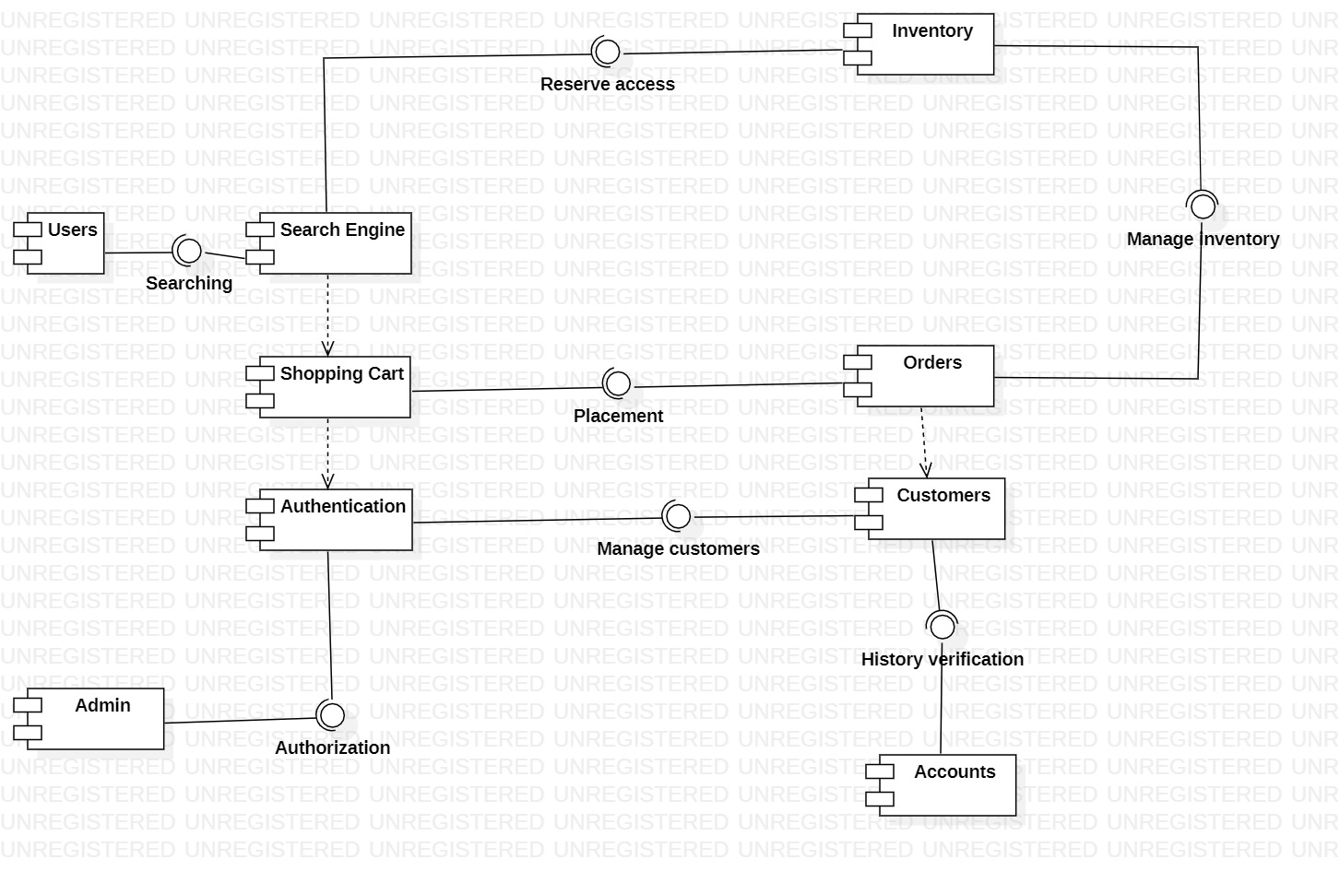

**Appendix C: To Be Determined List**

*<Collect a numbered list of the TBD (to be determined) references that remain in the SRS so they can be tracked to closure.>*